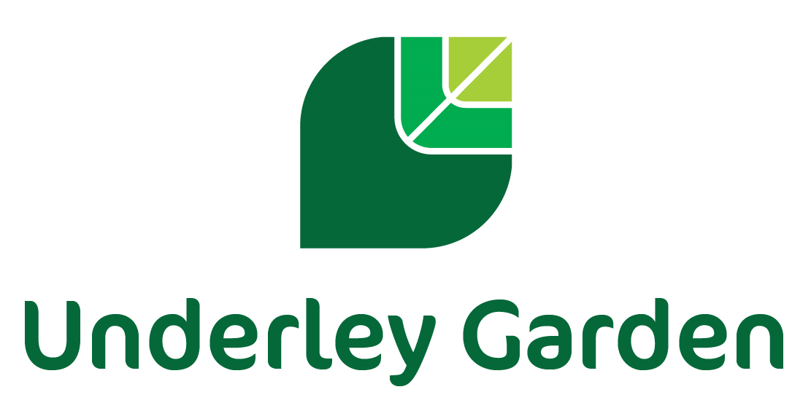

JOB DESCRIPTION

POST: Domestic Assistant/Cleaner

HOURS: 52 weeks with working hours of 9am – 5pm

SCHOOL: Underley Garden, Kirkby Lonsdale

REPORTS TO: Facilities Manager

We are seeking to appoint a Cleaner to join our team of cleaning staff at Underley Garden. The successful candidate will work as part of the Facilities Team whose role focuses on ensuring a safe, well maintained, and clean environment is sustained throughout the whole site. You must be dependable and trustworthy, comfortable working independently as well as being part of a larger team. Whilst prior cleaning experience is not essential it would be desirable.

Underley Garden is a large site which hosts a large school provision and a residential children’s home across several buildings. All children who attend the school and live within the home have EHCP’s due to their special educational needs.

Review and Amendment:
This job description will be reviewed annually and may be subject to modification and amendment following consultation between the Senior Leadership Team and the post holder.

Key duties
- Cleaning of all areas within the site (education, care and administrative buildings) including closure cleaning;
- Sweeping, vacuum cleaning and mopping of floors;
- Emptying litter bins;
- Polishing and dusting of surfaces and fixtures and fittings;
- Cleaning of bathrooms, changing rooms, toilets and shower facilities, including replenishment of paper towels, toilet rolls and other disposables;
- Using appropriate powered equipment, with necessary training (e.g. floor buffer);
- To notify line management or other Senior member of staff, of any damage to buildings and equipment or anything you see that may be dangerous to pupils or staff;
- To inform Cleaning Supervisor / Facilities Manager of matters requiring attention e.g. light bulb replacement, blocked toilets etc;
- To inform Cleaning Supervisor / Facilities Manager when there is low stock of cleaning materials and other disposables etc;
- To undertake training in the correct use of cleaning equipment as appropriate;
- Additional cleaning for one-off occasions i.e. Open Evenings, Visits etc.
- Adhere to correct and secure storage of chemicals, disposables and equipment, as directed
- Adhere to company rules regarding correct use of cleaning equipment and personal protective equipment (PPE).
- Undertake any other additional duties commensurate with the grade of the post.

Other General Duties
- Implement and uphold the policies, procedures and codes of practice of the company, including customer care, finance, data protection, ICT, health & safety, anti-bullying and safeguarding/child protection.
- Understand the need of the children who attend the school and live within the children’s home
- Understand the importance of inclusion, equality and diversity, when working with pupils and with colleagues, and to promote equal opportunities for all.
- Uphold and promote the values and the ethos of the company.
- Take a pro-active approach to health and safety, working with others in the company to minimise and mitigate potential hazards and risks, and actively contribute to the security of the site, e.g. challenging a stranger on the premises.
- Participate and engage with workplace learning and development opportunities, subject to the company’s training plan, working to continually improve own performance and that of the team.
- Work with colleagues to provide a safe environment for pupils.
- Undertake appropriate training and share skills and expertise with others / team, as required.

Other Job-related Duties
- To undertake other duties consistent with the scope of the post and within the competence of the post holder as required and directed by the Senior Leadership Team.
- All employees are obliged to adhere to the company code of professional conduct, which is produced in the Employee Handbook.

Safeguarding
The post holder will:
- Know how to identify potential abuse or neglect and follow safeguarding procedures.
- Be aware, following training, of the current legal requirements, national policies and guidance on the safeguarding and promotion of the well-being of service users.

Equal Opportunities
At all times and on all occasions to promote and comply with the company commitment to Equal Opportunities.

Health and Safety
Have a primary duty of care to self and ensure that appropriate health and safety practices are performed effectively to self and others.

Confidentiality
It is expected that all Underley Garden employees understand the nature of the work is confidential and details about users of our services should not be divulged to members of the public. If there is a breach of this confidentiality, this may result in disciplinary action being taken.

Other Duties and Responsibilities
A job description can never be fully descriptive and exhaustive of unforeseen changes or circumstances. It is expected that staff will, within reason, respond to unforeseen circumstances and emergencies as they arise, commensurate with their qualifications, experience and the situation.

This job description sets out the duties of the post at the time it was drawn up. The post holder may be required from time to time to undertake other duties within the school as may be reasonably expected, without changing the general character of the duties or the level of responsibility entailed.

THE PERSON SPECIFICATION

Essential Skills and Competencies

- Good inter-personal skills
- Ability to use a wide range of cleaning equipment and to follow the company cleaning guidelines.
- Willing to carry out all reasonable cleaning tasks as directed by the Senior Leadership Team.
- Willing to work as part of a team, but also prepared to undertake tasks independently.
- Willing and able to follow health and safety guidelines and training.
- Have a flexible approach and willing to use own initiative.
- Be punctual and reliable.
- Be aware of the importance of confidentiality & safeguarding procedures
- Able to lift/move equipment.
- Able to communicate effectively both verbally and in writing where necessary

Desirable Experience and Competencies

- Experience of working within a domestic cleaning team
- Experience of working within a care and educational setting
- Experience of working with listed buildings
- Experience of working within a Conservation Area
- Competent in the use of MS Office including Word, Excel and Outlook

Personal Characteristics

- Must be honest, trustworthy and reliable
- Able to satisfy DBS check that there are no impediments to working with children and young adults
- Empathy with young people particularly those with additional special needs
- Seeks opportunities for personal development
- Able to work under pressure and meet deadlines

