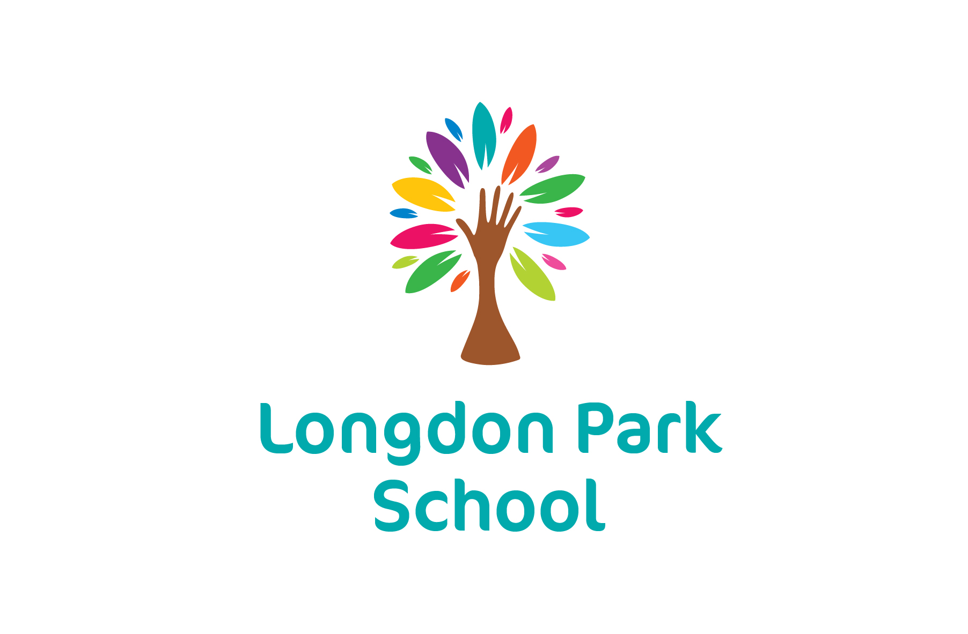

Job Description: Teaching Assistant

Reports to: Headteacher, Class Teacher
The post holder will be expected to liaise with staff across the organisation to ensure a consistency of approach regarding standards, support, transition and quality of provision.

Review and Amendment: This job description will be reviewed annually and may be subject to modification and amendment following consultation between the Headteacher and the post holder.

Purpose of the Job
To work under the direct instruction of an assigned teacher, usually in the designated learning environment with a teacher, to support access to learning for students and provide general support to the teacher in the management of pupils and the classroom. Work may sometimes be undertaken outside the main teaching area - this may include off site locations including college settings. To lead small parts of lessons with a small number of students. To share the school’s responsibility to support and promote the learning, personal development and well-being of all students.

Key Result Areas
To work under direct supervision/instruction to support access to learning by:
- Attending to the welfare and learning needs of students
- Working with and leading small groups or one to one
- Undertaking general clerical/organisational support for the teacher

General Responsibilities
The post holder will:
- Safeguard and promote the welfare of children and young people
- Work in accordance with professional practice, statutory and legal requirements and the policies of Longdon Park School
- Take on specific tasks related to the day to day administration and organisation of the school
- Take responsibility for specific areas of work which will be reviewed annually then negotiated and agreed within the performance management cycle and school improvement process
- Take on any additional responsibilities which might from time to time be determined

Duties and Accountabilities

The post holder will support the teacher by:
- Preparing the classroom and other learning areas as directed for lessons and clearing afterwards
- Assisting with the display of pupil’s work
- Being aware of individual pupil problems/progress/achievements and reporting any concerns to the teacher as agreed
- Undertaking pupil record keeping as requested
- Being aware of/working within planned learning activities
- Contribution to planning e.g. for individual pupils, general literacy/numeracy
- Working with the teacher in managing pupil behaviour and reporting as appropriate
- Gathering/reporting information from/to parents/carers as directed
- Providing clerical/administrative support e.g. photocopying, typing, filing, etc.

The post holder will support students by:
- Supervising and providing support for pupils, ensuring their safety and access to learning
- Assisting with the development and implementation of IEPs/IBPs/PHPs/RA’s
- Establishing good relationships with pupils, acting as a role model and being aware of and responding appropriately to individual needs
- Promoting the inclusion and acceptance of all pupils
- Encouraging pupils to interact with others and to engage in activities led by the teacher
- Encouraging pupils to act independently as appropriate

The post holder will support the curriculum by:
- Supporting pupils to understand instructions and tasks
- Supporting pupils in respect of local and national learning strategies e.g. literacy, numeracy, KS2/KS3 etc as directed by the teacher
- Supporting pupils using ICT as directed
- Preparing and maintaining equipment/resources as directed by the teacher and assisting pupils in their use
- Leading planned activities and tasks according to whole school need

The post holder will support the school by:
- Being aware of and complying with policies and procedures relating to safeguarding, child protection, health, safety and security, confidentiality and data protection, and reporting all concerns to an appropriate designated person
- Being aware of and supporting difference and ensuring all pupils have equal access to opportunities to learn and develop
- Contributing to the overall ethos/work/aims of the school
- Appreciating and supporting the role of other professionals
- Attending relevant meetings as required
- Participating in training and other learning activities and performance management as required
- Assisting with the supervision of pupils out of lesson times, including before and after school and at breaks / lunchtimes as required
- Accompanying teaching staff and pupils on visits, trips and out of school activities as required

Health and Well-Being
The post holder will:
- Be aware of the current legal requirements, national policies and guidance on the safeguarding and promotion of the well-being of children and young people.
- Know how to identify potential child abuse or neglect and follow safeguarding procedures.
- Know how to identify and support children and young people whose progress, development or well-being is affected by changes or difficulties in their personal circumstances, and when to refer them to colleagues for specialist support.

Team Working and Collaboration
The post holder will:
- Work as a team member and identify opportunities for working with colleagues and sharing the development of effective practice with them.

Other Duties and Responsibilities
A job description can never be fully descriptive and exhaustive of unforeseen changes or circumstances. It is expected that staff will, within reason, respond to unforeseen circumstances and emergencies as they arise, commensurate with their qualifications, experience and the situation.

